CS 2340 Project 2 Screenshots
  - By Ndubueze Echefu
So in one of the submission rules: I have to screenshot a list of numbers in the data area and the results in the output area. For flexibility and user-friendly reasons, I went with a more different approach.
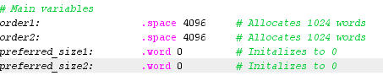
In this one, I have the order spaces and preferred_sizes words. There isn’t a list of integers here due to making the program more interactive. Instead of hard coding it in, I gave the user the freedom to input their own lists.
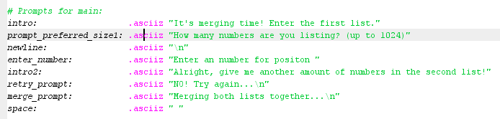
Here are the following prompts I used in this program. I made sure that when the user is creating lists, that the list cannot be lower than 1, or higher than 1024 (x4 = 4096 spaces).

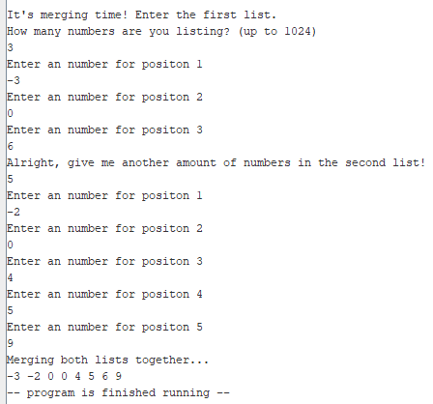
Here’s the output. This one’s an example of the following in the prompt: “Another example is to merge (-3, 0, 6) and (-2, 0, 4, 5, 9) to produce (-3, -2, 0, 0, 4, 5, 6, 9). You may assume the number of integers in each list is known.”
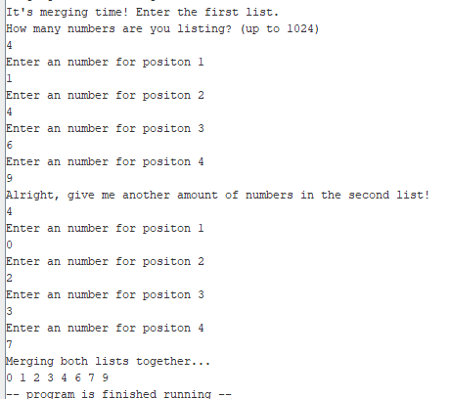
Another example following this prompt: “given two ordered lists (1, 4, 6, 9) and (0, 2, 3, 7) as input arguments, "merge" should generate a new list (0, 1, 2, 3, 4, 6, 7, 9) which is also ordered.”
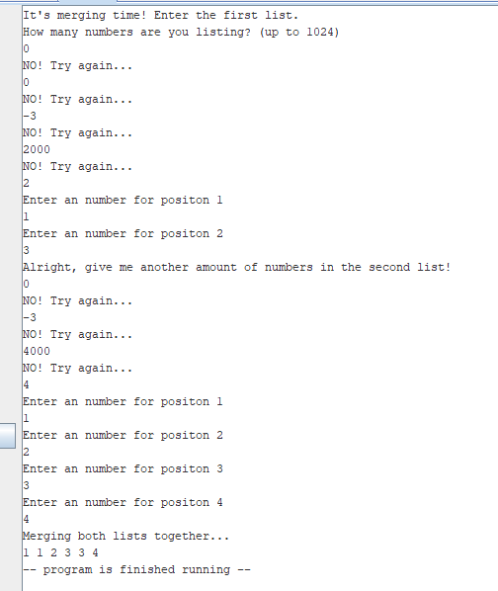
Further proof that the limitation even works.

Despite all of this, it still works as intended!

